Checkers Game Project Report
Noor Sheikh
Brandon St Amour
Manish Kumar
Date of this version (2020-05-02)
This report talks about the Checkers Game project which we have developed as part of the SWE/ISA 681 security project requirements. It will explain the design and architecture of the project and explain why it is secure by presenting an assurance case for this project.

Introduction
The project is being developed as a secured web application that can support multiple instances of the game at the server-side and is scalable. The game is called Checkers game which is a two-player game where one player is assigned one color of checkers and the other is assigned a different color. Each player has 12 checkers to start the game. The object of the game is to capture the other player's checkers or make them impossible to move.

Project Requirements
The game requirements are as follows:
- The game must support at least two humans.
- The game moves must be more complex than a single digit or letter as a possible move.
- The game selected must enable players' decisions (e.g., moves) to interfere with other player's decisions in at least some cases.
- It should work on the TCP/IP network.
- It should be scalable to at least 50 simultaneous games at the same time.
The security requirements for the project are as follows:
- It should cover Confidentiality, Integrity, and Availability aspects.
- The records of all the games played by the user should be stored in a database.
- Use of security tools such as OWASP Zap, Fortify to make sure the server-side is robust and has no security issues.
- Various other aspects of the security principles being taught in the lectures should be covered as part of it.

Development Tools Used
The project has been developed by using the following frameworks.

Server Side
- Symfony PHP framework
- MySQL database

Client Side
- React UI framework for front end
- Typescript language used
- Bootstrap for CSS

Distribution Packaging
- Available as docker images to deploy on cloud platforms such as AWS.

Design and Architecture
The server application is being developed using Symfony web framework to provide REST APIs so that client can interact with the server. The server will support the following requests from the client.
- Client registration/login functionality
- Saving/Retrieving game states
- Only Authenticated requests allowed
- Input validation
- HTTPS requests
The client application will have the following functionalities
- User Login/Logout functionality
- React based Checkers Game UI to play the game
- Save game states and continuously update with the server
- Input validation for the inputs from the client
- Bootstrap functionality from React framework

Web Application Interaction
The web application can also be deployed on the cloud infrastructure using Docker to avoid the hassle of installing all dependencies manually on a machine.

High Level Design Diagram
The following diagram illustrates how the server will interact with multiple clients at a high level.
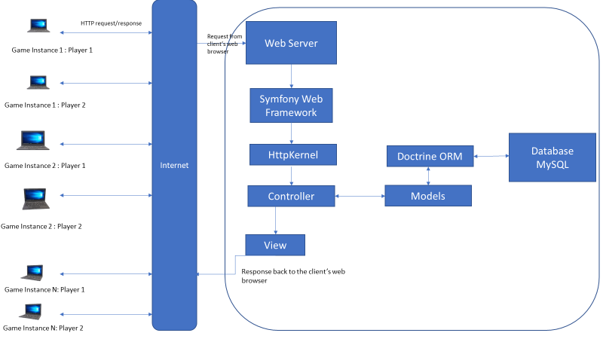
Let us discuss a workflow example to illustrate the details of how the requests will be handled by the web server.
- The user sends a request to the web server through the browser for example: https://checkersgame.com/login
- The browser will send a request to the web server.
- The web server will send it to the Symfony web framework.
- HttpKernel is the core component of the Symfony web framework. HttpKernel resolves the controller of the given request and then forwards it to the target controller.
- The business logic is executed in the target controller.
- The controller will interact with Model, which will, in turn, interact with the MySQL database through Doctrine ORM.
- Once the controller completes the process, it either generates the response itself or through View Engine and sends it back to the webserver.
- Finally, the response will be sent to the requested browser by the web server over the internet.

Database Schema
The project uses MySQL as a database to store the following information
- Registered users information
- Game (which has all details of the game including game moves)
The following tables show the schema for all the tables created for the project.

List of all tables
+------------------------+
| Tables_in_checker_game |
+------------------------+
| game ||
| user |
+------------------------+

User Information
The table will be used to authenticate the users as only authenticated users are allowed to play the Checker game.
+------------+--------------+------+-----+---------+----------------+
| Field | Type | Null | Key | Default | Extra |
+------------+--------------+------+-----+---------+----------------+
| id | int(11) | NO | PRI | NULL | auto_increment |
| first_name | varchar(100) | NO | | NULL | |
| last_name | varchar(100) | NO | | NULL | |
| username | varchar(100) | NO | | NULL | |
| email | varchar(100) | NO | | NULL | |
| password | varchar(100) | NO | | NULL | |
+------------+--------------+------+-----+---------+----------------+

Detailed Status of the Game
The table stores information about the game such as the player1 and player2 scores, state along with the timestamp and other details.
+---------------+--------------+------+-----+-------------------+----------------+
| Field | Type | Null | Key | Default | Extra |
+---------------+--------------+------+-----+-------------------+----------------+
| id | int(11) | NO | PRI | NULL | auto_increment |
| player1_id | int(11) | NO | MUL | NULL | |
| player2_id | int(11) | YES | MUL | NULL | |
| winner_id | int(11) | YES | MUL | NULL | |
| board_state | varchar(255) | NO | | NULL | |
| created_at | datetime | NO | | CURRENT_TIMESTAMP | |
| updated_at | datetime | YES | | NULL | |
| player1_score | int(11) | NO | | NULL | |
| player2_score | int(11) | NO | | NULL | |
| game_status | varchar(15) | NO | | NULL | |
| player_turn | int(11) | NO | | NULL | |
| game_locked | int(11) | NO | | NULL | |
+---------------+--------------+------+-----+-------------------+----------------+

Routes in Server
-------------------------- -------- -------- ------ ------------------------------------
Name Method Scheme Host Path
-------------------------- -------- -------- ------ ------------------------------------
_preview_error ANY ANY ANY /_error/{code}.{_format}
_wdt ANY ANY ANY /_wdt/{token}
_profiler_home ANY ANY ANY /_profiler/
_profiler_search ANY ANY ANY /_profiler/search
_profiler_search_bar ANY ANY ANY /_profiler/search_bar
_profiler_phpinfo ANY ANY ANY /_profiler/phpinfo
_profiler_search_results ANY ANY ANY /_profiler/{token}/search/results
_profiler_open_file ANY ANY ANY /_profiler/open
_profiler ANY ANY ANY /_profiler/{token}
_profiler_router ANY ANY ANY /_profiler/{token}/router
_profiler_exception ANY ANY ANY /_profiler/{token}/exception
_profiler_exception_css ANY ANY ANY /_profiler/{token}/exception.css
login ANY ANY ANY /api/login
create_game_board ANY ANY ANY /api/secure/game-board/create
update_game_board ANY ANY ANY /api/secure/game-board/update/{id}
get_game_board GET ANY ANY /api/secure/game-board/{id}
current_games GET ANY ANY /api/secure/current-games
add_game_move ANY ANY ANY /api/secure/game-move/add
update_games_status GET ANY ANY /api/secure/update-games-status
register_user ANY ANY ANY /api/user/register
user_leader_board ANY ANY ANY /api/secure/leaderboard
api_login_check ANY ANY ANY /api/login_check
-------------------------- -------- -------- ------ ------------------------------------

Installation instructions
The setup can be deployed on a local machine as well as a cloud environment such as AWS/Azure/Google Cloud network if needed.

Local Machine Installation
The installation instructions are common for all platforms (Windows/Unix/Linux)
- git clone https://github.com/noorsheikh/checker-game (Ask for permission to clone the repository)
- Install prerequisites for the web application (Docker is the essential component).
- Generate certificates and keys for the server using OpenSSL and copy it to server/httpd-conf directory named as server.key and server.crt.
- Generate certificates and keys for the client using OpenSSL and copy it to the client directory named client.key and client.crt.
- The commands to generate certificate for server is :
openssl req -x509 -out server.crt -keyout server.key \
-newkey rsa:2048 -nodes -sha256 \
-subj '/CN=localhost' -extensions EXT -config <( \
printf "[dn]\nCN=localhost\n[req]\ndistinguished_name = dn\n[EXT]\nsubjectAltName=DNS:localhost\nkeyUsage=digitalSignature\nextendedKeyUsage=serverAuth")
- Go to checkers-game root directory and execute the following command :
docker-compose build –no-cache
- To start the project : docker-compose up.
- Open Google Chrome/Firefox browser and enter the url : https://localhost:3000

Cloud Setup Installation
Kindly note that the setup is not yet online on AWS due to resource constraints in the free tier account.
- Login to AWS console and create a new S3 bucket.
- Deploy react app using yarn deploy and then copying the build folder to the AWS s3 bucket.
- Enable static website hosting to access the react frontend app.
- Follow the AWS recommended steps to enable HTTPs.
- Create EC2 instance to deploy Symfony server.

Operating Instructions

Local Machine Setup
- Login to the website using the URL : https://localhost:3000
- Register/Sign In using the username and password.
- After successful signup Click on New Game.
- Wait for the other player to join the game as it’s not allowed to play a game individually.
- Logout after playing the game.

Cloud Access Setup
Access the URL for playing the game https://<registereddomain>.com

Instructions for playing the game

Number of Players
The game is a two-player game that works on a TCP/IP network. The user can connect to the web application using their username and password.

Rules of the Game
- The two players alternate turns and can only move their pieces.
- The dark squares are the only ones that may be occupied on the board. The light squares must remain empty.
- Each turn involves the moving of one piece, which can consist of a piece moving forward to a diagonally adjacent square that is unoccupied, or jumping forward over an occupied diagonally adjacent square, provided that the square beyond is also empty.
- If a player jumps over their opponent’s piece, they have successfully captured that piece and it is removed from the game.
- When a piece reaches the furthest side of the board it becomes a king. When this happens, the player stacks an additional piece on top of the original to signify the change.
- A piece may only move forward, but kings can move diagonally forwards as well as backward.
- Multiple pieces may be jumped by a piece and kings if there are successive unoccupied squares beyond each piece that is jumped.
- The game is won by either capturing all your opponent’s pieces or trapping their pieces, disallowing them to make any more moves.

Why is the software secure ?
This section describes why we think the software is secure. It takes the help of the assurance case to describe it. This section is continuously modified as we make progress in the development of this software.

Assurance Case Summary
The following figures give a summary of why the application is secure. The details are provided in section 5.2.

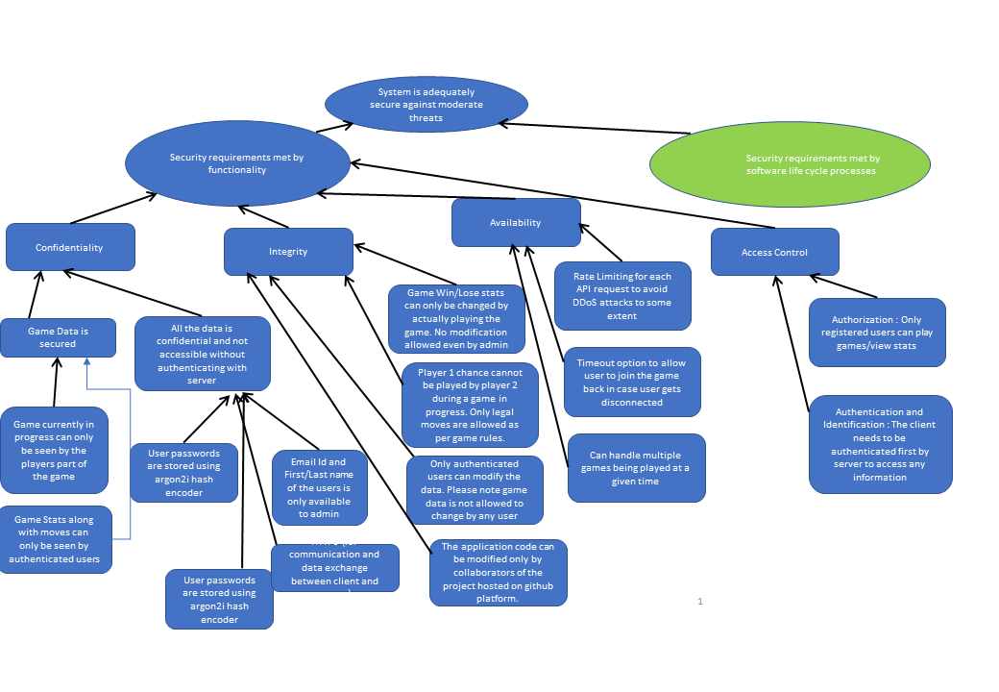
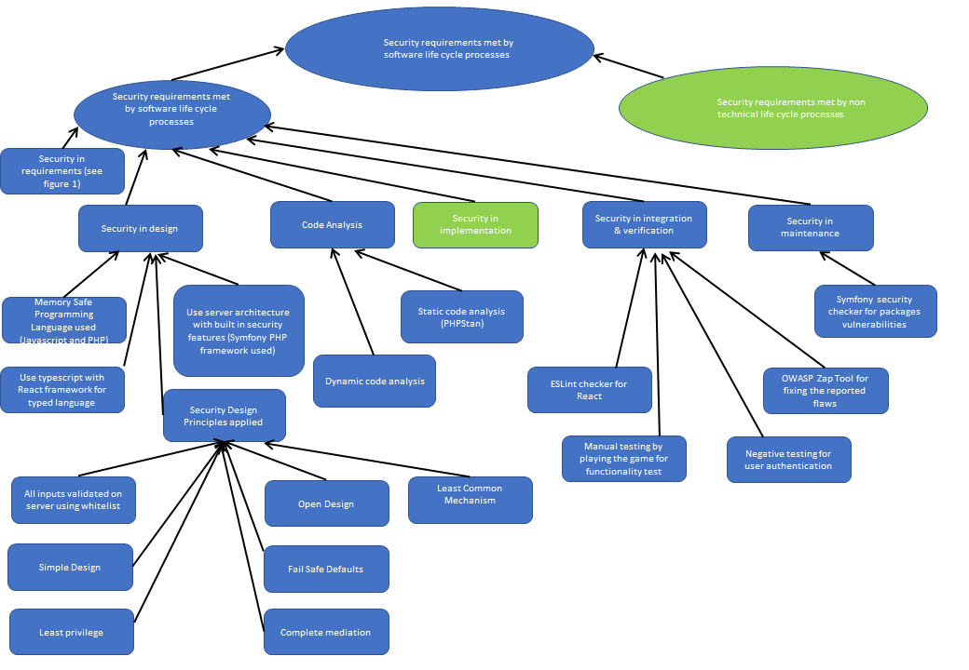

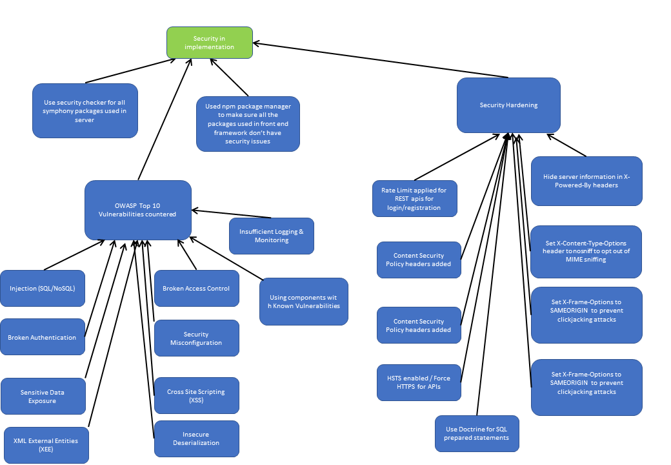

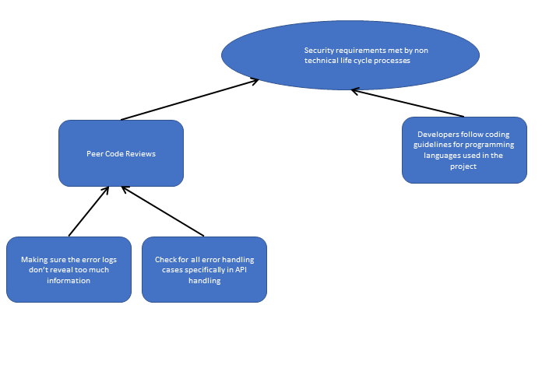

Assurance Case Detail
We will start with an explanation of how we have taken care of the 3 most important requirements for security i.e. Confidentiality, Integrity, and Availability. We will continue with other aspects of the assurance case after it.

Confidentiality
It is one of the first requirements which we have fulfilled by doing the following steps.
- The passwords are not stored in plain text. They are stored in the database after using Argon2i password hasher which is better than bcrypt (high hashing cost) and more secure. The database never stores the passwords in plain text format. It is performed in the AuthController.php controller section where the request from the client is decoded and then the provided password is being matched against the stored database entry to verify the correctness.
- All the text, images, and other resources are served from the website itself and do not use any external resources.
- During registration, the email id provided is also stored in a secured database that cannot be retrieved from any client.
- There is a user token provided to any registered user who logins into the server with a validity of 30 minutes. Each user is assigned a unique token so that all the requests generated from the user will provide this unique id along with each request to the server. JWT authentication bundle is used to generate such tokens. Once the token expires, if the user tries to request some data again using the same token the request will not succeed and the user will be forced to log in again to get a new token.
- All the communication happens over the HTTPS channel. It is used to encrypt all communication between client and server so that there is no eavesdropping possible. It is enabled in the Apache server by enabling SSL module and specifying the certificate and private key in the apache2.conf file.
- Symfony provides a security module where we have a configured firewall to prevent unauthorized users to access other URLs. The configuration is stored in security.yaml file.
- The game moves will be stored for each game and will be available to only authenticated users. The game statistics are not available when the game is in progress.
- The win/loss record of the completed games should be available only to authenticated users.

Integrity

Integrity makes sure that the data cannot be modified in an unauthorized or undetected manner.
            - We do not allow to modify the user information from the front-end application once the account is created. It is possible only by accessing the database and then modifying it. It may be possible to modify it in a future release if needed.
            - The game information such as the current move, the history of game moves, the players which are part of the game is not modifiable by a user explicitly. The JSON requests from the client-side is sent encrypted along with user token only from the game interface. Once the game history is recorded it can only be changed by accessing the database at the backend.
            - Modification to the source code of the game application is not possible without authorization from the GitHub. The code is available to modify only the trusted collaborators for the project.
            - The game rules should be strictly followed such that only valid moves are allowed and only the current player can make a legal move.
            - The game moves/stats can only be changed by playing the game.

Availability

Availability is usually measured in terms of reliability. If we make the software reliable then it will automatically take care of the availability. The game application needs a high-reliability factor as the game is played in real-time.
- To minimize the impact of Denial of service attacks we have deployed the application on AWS cloud where it provides Amazon Shield service which safeguards our application.
- There is a timeout associated with each game so that the game does not pause forever waiting for a user. If the user is disconnected from the game longer than the defined timeout then the game cannot continue and will be forfeited.
- The server supports simultaneous gameplay and for the current version. we have enabled only 1 server instance.

Applying Security to the Server application
The server has a default configuration provided when we install it, but it does not protect by default from the top OWASP vulnerabilities. To achieve that protection the following steps were taken.
            - Using Components with Known Vulnerabilities: Securing the packages which the server is using is important for us. We execute the Security Checker package at regular intervals to make sure that all the packages are free from known vulnerabilities. It avoids the attacker being able to exploit known vulnerabilities on unpatched systems.
            - We have used the OWASP ZAP tool to run the security scan for the website and determine all the top OWASP vulnerabilities to which our application is exposed. We fixed those by making changes on the server-side. For Apache, the changes were done in apache2.conf file to prevent Cross Site Scripting (XSS) attacks, ClickJacking, etc.
            - We have also enabled nosniff in X-Content-Type-Options HTTP response header in Apache to opt-out of MIME-type sniffing.
            - Symfony provides efault protection against SQL injection attacks. It is provided by the Doctrine Object Relational Mapper (ORM) module through which we do not write raw SQL queries, instead use Doctrine Query Language (DQL) by creating entities which are an abstraction.
            - Input Validation is done for all the inputs received from the client-side. The whitelist method is used to validate all the inputs using regular expressions. It applies to the username, password, game moves, etc.
            - In Symfony, we have disabled to allow switching from one user to another user without logging out. It is done in security.yaml file.
            - Content Security Policy is also enabled in the Apache server to mitigate CSS and data injection attacks.
            - If the password is incorrect the server always responds with generic responses so that it does not expose any extra information to the user.
            - We have removed the footer information in error pages provided by the server so that attacker cannot use the version information of the server to determine known vulnerabilities.
            - Insecure Deserialization is avoided as the application only accepts JSON and HTML fields.
            - XML External Entities XXE: We have used Symfony v4 which is not vulnerable to XSS based attacks. Moreover, we are not using any XML data to do any kind of processing.
            - Unvalidated Redirects and Forwards: We are not using any redirects or forwards on the server-side.
            - Broken Authentication: The server allows only authenticated requests to access resources. It also uses an encrypted token for each session which is destroyed after logout/timeout.
            - We are also doing logging and monitoring in a controlled manner so that it does not provide misleading information.
            - Cookies have HttpOnly by default set to true and samesite is also set to lax in framework.yaml file.
            - Rate Limit: The rate-limiting is a feature used to mitigate DDoS as well as dictionary-based attacks to some extent. To implement this feature, we are using RateLimitBundle package for the Symfony server. It can be applied per function or per controller basis. For example: @Ratelimit(methods={"POST"}, limit=100, period=10); // 100 POST requests per 10 seconds

Project Snapshots

